# Web Designing Assignment:

* + - * + Module 3) HTML
* Are the HTML Tags and Elements the Same Things ?

Ans:- **Tag:** A tag is a specific set of characters that define a particular element within an HTML document. Tags are enclosed in angle brackets, such as <div>, <p>, <img>, etc.

**Element:** An element consists of a start tag, content, and an end tag, along with any attributes that are associated with the tag. For example, <p> is the start tag, content is the text or other elements within the <p> element, and </p> is the end tag. The combination of start tag, content, and end tag makes up an element

* Ex;-
  + 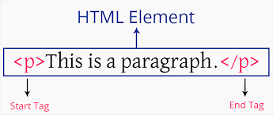
* What are tags and attributes in HTML?

Ans :- Tags are the building blocks of HTML documents. They are used to define the structure and elements of a webpage.

Tags are enclosed in angle brackets < > and usually come in pairs: an opening tag and a closing tag.

Attributes provide additional information about an HTML element. They are specified within the opening tag of an element.

* What are void elements in HTML? With Example.

Ans:-Void elements, also known as self-closing or empty elements, are HTML elements that do not have a closing tag. Instead, they self-close within the opening tag.

Ex:-

<img src="example.jpg" alt="Example Image">

<p>This is a paragraph.<br>This is a new line.</p>

* What are HTML Entities? With Example.

Ans:-HTML entities are special codes used to represent characters that have special meaning in HTML, such as reserved characters like <, >, &, and characters with special formatting or display requirements. These entities are particularly useful when you want to display characters that might otherwise be interpreted as HTML code, or when you need to include characters that are not easily typed on a keyboard.

Ex:-

lt;: Less than <

&gt;: Greater than >

3 . &amp;: Ampersand &

* What are different types of lists in HTML? With Example.

Ans:- In HTML, there are three main types of lists: ordered lists (<ol>), unordered lists (<ul>), and definition lists (<dl>). Each type serves a different purpose and is formatted differently. Below are examples of each type:

Ex;- Ordered List ;-

<ul>

<li>Chocolate Cake</li>

<li>Black Forest Cake</li>

<li>Pineapple Cake</li> </ul>

Un Ordered List ;-

ul

{ list-style-type: square; }

ulData list :-

<dl> <dt>Bread</dt> <dd>A baked food made of flour.</dd> <dt>Coffee</dt> <dd>A drink made from roasted coffee beans.</dd> </dl>

* What is the ‘class’ attribute in HTML? With Example.

Ans In HTML, there are three main types of lists: Ordered lists , Unordered lists , Description lists In HTML, the “class” attribute is used to assign one or more classes to an HTML element. A class is a named group of elements that share common properties and styles.

Example

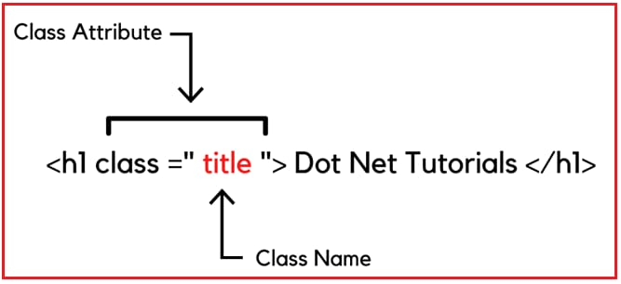

* What is the difference between the ‘id’ attribute and the ‘class’ attribute of HTML elements? With example

Ans:-The id attribute is used to identify a unique element in the HTML document , while the class attribute is used to identify a group of elements

Example

Id attribute

  
Class attribute



* What are the various formatting tags in HTML ?

Ans:-The formatting can be used to set the text styles (like – bold, italic, or emphasized, etc.), highlighting the text, making text superscript and subscript, etc.

* How is cellpading different from cellspacing ? with example

Ans:-Cellpading   
Cellpadding specifies the space between the border of a table cell and its contents (i.e) it defines the whitespace between the cell edge and the content of the cell.

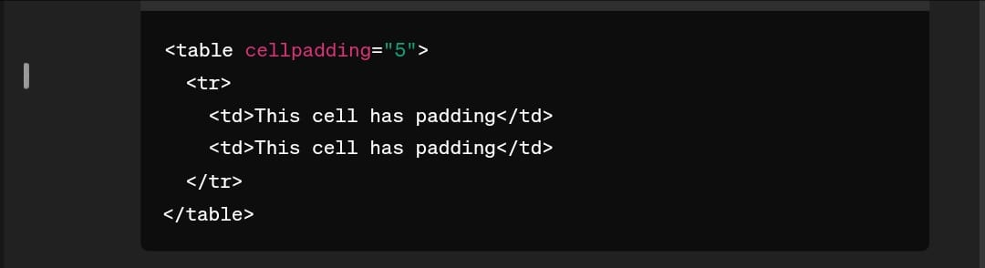

Cellspacing

Cellspacing specifies the space between cells (i.e) it defines the whitespace between the edges of the adjacent cells.

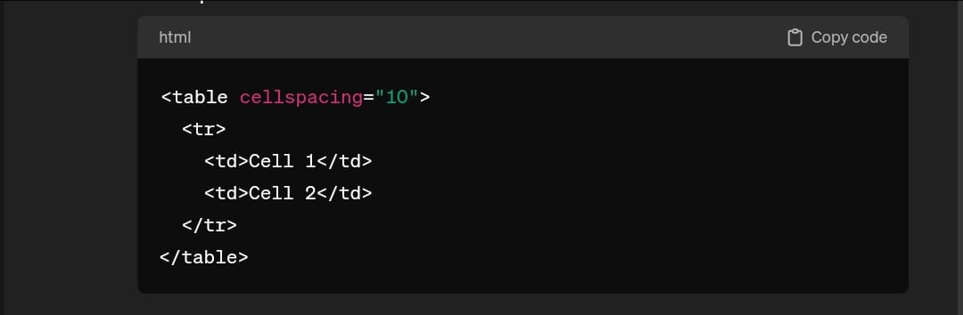

* How can we club two or more row or column into single row or column in an html table ? with example

Ans:-To merge two or more table cell in column , use the colspan attribute in HTML tag.

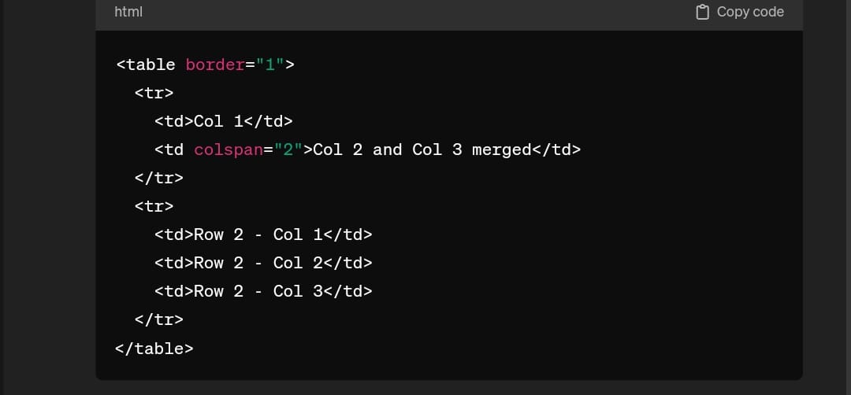

To merge two or more row cell , use the rowspan attribute .

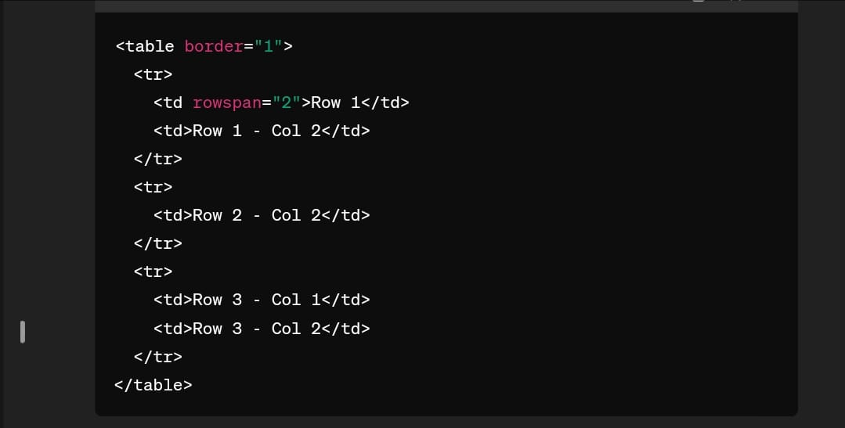

* What is the difference between a block-level element and inline element ?

**Ans:- HTML Block elements**,are used to structure the main content of a webpage. They typically start on a new line and take up the full width of their container

**Inline elements**are used within block-level elements to style or format specific parts of the content.

* How to create a Hyperlink in Html? With example

Ans Html links or hyperlinks connect one resource on the web to another. The resource may be an image, a web page, a program, a video clip, an audio clip, an element within a web page, etc , or anything that can be hosted on the internet.

Example

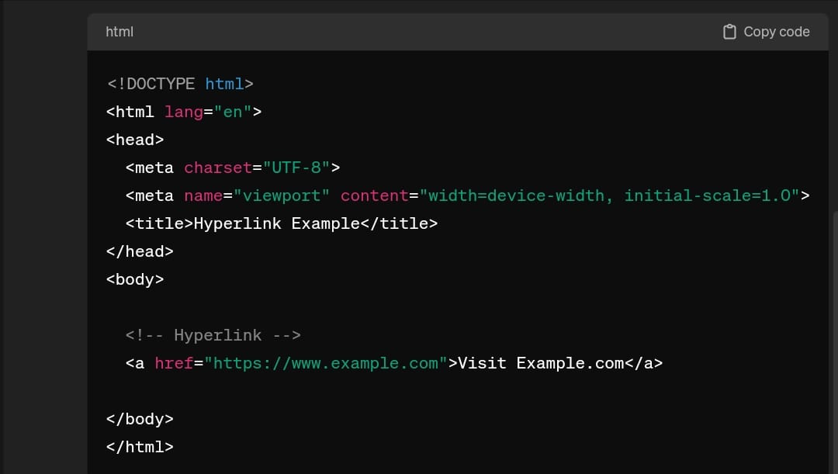

* What is the use of Iframe tag in html? With example

Ans The HTML <iframe> tag is used to embed a webpage within a webpage. It is also called an inline frame.

Example

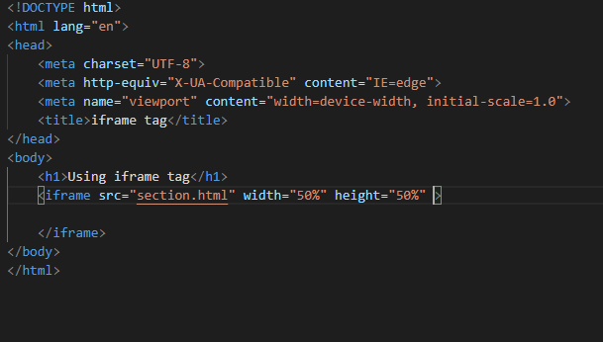

* What is the use of span tag ? explain with example

Ans The span tag is an inline container used to mark up a part of a text, or a part of a document.

Example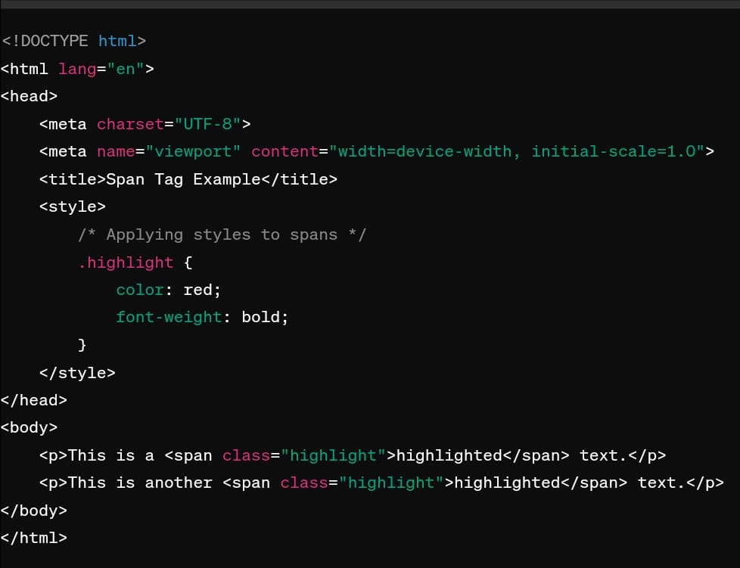

* How to insert a picture into a background image of a web page? With Example.

Ans:-To insert a picture into a background image of a web page, you can use CSS. Here's an example:

This CSS code sets the background image of the body and positions it accordingly. Then, it creates a container (#image-container) where the inserted image will be placed. The inserted image (#inserted-image) is positioned absolutely within this container, allowing you to control its placement on top of the background image. Adjust the positioning and styling properties as needed to fit your layout.

Example:-

css

Copy code

body {

background-image: url('background-image.jpg');

background-size: cover; /* Adjust as needed */

background-position: center; /* Adjust as needed */

}

#image-container {

position: relative;

width: 100%;

 height: 100%;

* How are active links different from normal links?

Ans:-Active links are typically links that are currently functional and lead to live web pages, while normal links can refer to any link, whether functional or broken. Active links are actively used and accessible, while normal links may or may not be functional at a given time.

* What are the different tags to separate section of text?

Ans:- We separate a section of texts in HTML using the below tags:

<br> tag – It is used to separate the line of text. It breaks the current line and shifts the flow of the text to a new line.

<p> tag–This tag is used to write a paragraph of text.

<blockquote> tag–This tag is used to define large quoted sections.

* What is SVG?

Ans :-SVG stands for Scalable Vector Graphics

SVG is used to define vector-based graphics for the Web

SVG defines graphics in XML format

Each element and attribute in SVG files can be animated

SVG is a W3C recommendation

SVG integrates with other standards, such as CSS, DOM, XSL and JavaScript

* What is difference between HTML and x HTML

Ans :- Multimedia: Both HTML and XHTML support various forms of multimedia, such as images, video, and audio.

Styling: Both HTML and XHTML offer a wide range of options for styling web pages.

Error handling: XHTML comes with a much stricter error handling.

Closing tags: HTML accepts that some elements may not contain the closing tag. XHTML expects that all elements with no exception include a closing tag.

Empty elements: HTML empty elements do not require a closing tag at the end. XHTML empty elements must always be closed.

Attribute values: Attribute values are not important in HTML. These are very significant in XHTML.

* What is logical tag and physical tags in HTML

Ans :-HTML, physical tags are used to provide visual formatting to text, while logical tags describe what the text should be.

Physical and Logical tags

1) Here are some examples of physical tags:-

Blockquote tag: <blockquote>.

Sample tag: <samp>.

Text without any formatting.

: Bold text.

<big>: Big text.

2) Here are some examples of logical tags:

<acronym>: Defines an acronym.

<address>: Defines an address element.

<cite>: Defines citation.

<EM>: For emphasizing something.

<STRONG>: For strongly

Logical tags are different from physical tags because physical tags are used to decide the appearance of the text and do not provide any information about the text.